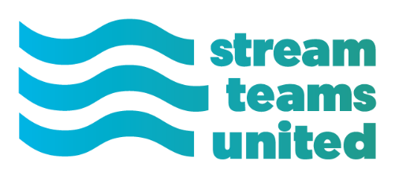
Stream Teams United Mini-Grant Application
Stream Teams United is offering mini-grant opportunities to member Stream Team Associations during 2020. Applications for the Fall 2020 mini-grant period are due by November 10, 2020 and will be awarded in December 2020.
There are three categories for the mini-grants: 1.) Education Supplies/Needs 2.) Travel assistance for volunteers to attend an event or meeting, and 3.) Stewardship supplies. Requests of up to $300 for each category will be considered during this fall’s grant cycle. A single Stream Team Association can apply for funding under each of the categories. Your application should be approved by your Board President.
To apply for a mini-grant, simply fill out the application below and attach a one or two paragraph summary of the request and the financial need for the grant. Scan and/or email your application to mary@streamteamsunited.org or mail to PO Box 483, Shelbina, MO 63468 by November 10, 2020.

Application: Stream Teams United mini-grant – Fall 2020
Stream Team Association Name: ___________________________________________________
Board President Name: __________________________ Phone __________________________
Does your Association currently have its own 501(c)(3) status? (Highlight or Bold) Yes No
Which category of mini-grant are you applying for (Highlight or Bold your answer):
- Education Supplies/Needs
- Travel Assistance
- Stewardship Supplies
What is the total amount of your request? ______________________________
Please list your Project Budget below:

On the following page, please describe the project and the financial need for the request. 400 Word Limit
Project Summary and Financial Need (400 word limit):

